Photographs for Analysis

1.

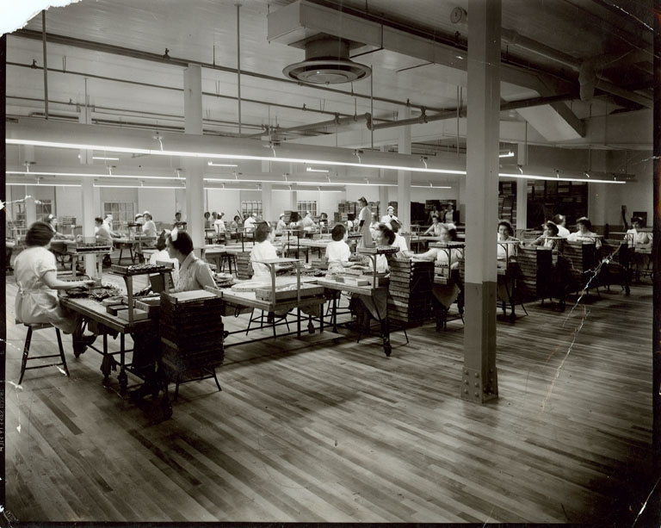

Chocolate hand dippers at Ganong Bros. Limited
Photo 1989.7.139

2.
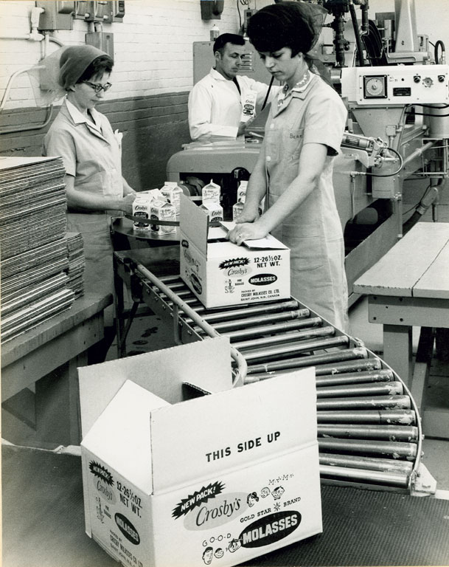
Assembly Line, Crosby’s Molasses
Photo 2002.12.13

3.
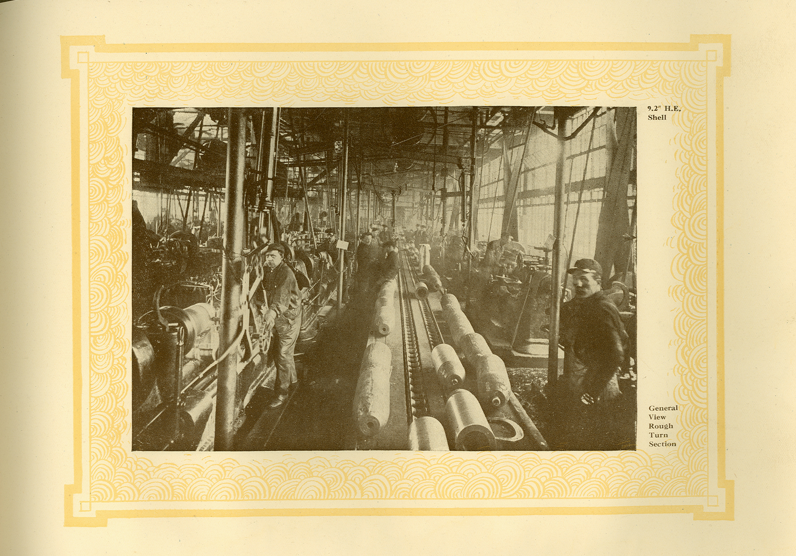

Assembly Line, High Explosives
High Explosives Shells – pg15

